**RENAISSANCE TRUST**

**Renaissance is a Secular, Non-Profit and Non-Political Voluntary Organization registered in January 1983, involved in development activities in the District of Pudukkottai, Tamil Nadu, for the past 35 years. Renaissance is recognized under State Law and holds several recognitions across domains of social cause.**

**Renaissance among its various activities is running a special school 'MALARCHI' created solely with the purpose of helping the cause of mentally challenged, multiply disabled and autistic Children at Kalamavoor, near Keeranur in Pudukkottai District.**

**Malarchi Residential School of Renaissance takes care of around 75 Intellectually challenged children including 20 Orphans.**

**Renaissance offers an Individual Educational Program for every student, aimed at social and economic independence, which incorporates special education, regular academic program through trained staffs, therapeutic interventions and vocational training. Also it offers speech, occupational and physiotherapy, life skills training, Yoga, computer education, music and dance, weight management and physical fitness, sports and extracurricular activities, counselling, behaviour modification, diagnostics and assessment facilities, and family counselling.**

**E.mail:** [**renaissance.mahalingam@gmail.com**](mailto:renaissance.mahalingam@gmail.com)

**WebSite: www.renaissance35.com**

**Story of Renaissance**

Renaissance is committed to support the underprivileged sections of society in which it operates. A not-for-profit initiative aimed at fulfilling the social responsibility towards a more equitable society.

The days of renaissance started way back in early 1980’s with a concern to help the Tamil repatriates from SriLanka who were the original inhabitants of South India. Being deprived of basic facilities, these peoples faced lots of hardships to meet their daily needs and the future was in the peril of vanishing in the darkness.

It was on 27-01-1983 the trust was formed to serve and unite the repatriates in providing support and service for their well-being to have a basic living in Tamil Nadu.

This service gained momentum and served more than what it is meant for and further become a full-fledged initiative to serve not only the repatriates, but all socio-economically backward peoples, especially the most backward district of Tamil Nadu namely Pudukottai.

The service ranges from Health Awareness, Non-Formal Education, Skill Development, Employment Training, Water Management, etc.

**Vision: Malarchi School**

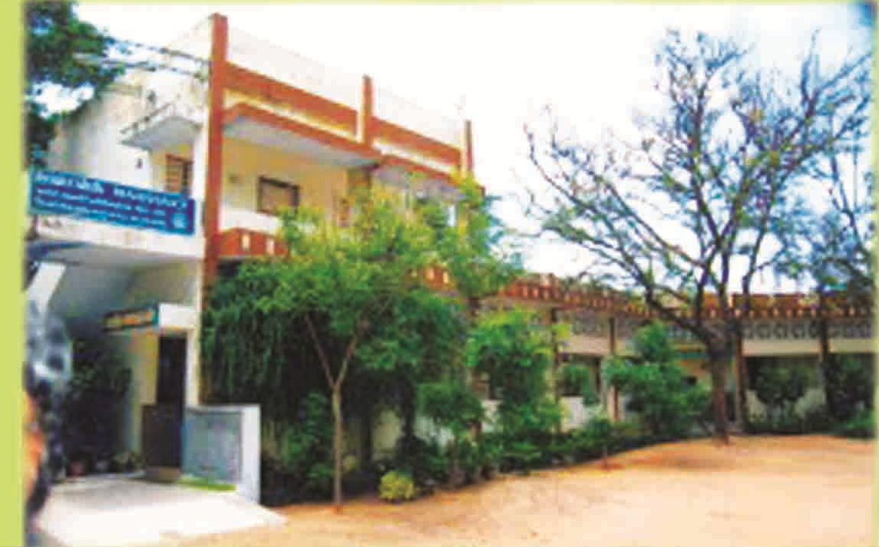

In 1990 a survey from the trust found that there were numerous children’s who are mentally challenged are left to fend themselves not only by their own parents but the society itself. These Gods Creation was in an in-human condition that no government organization was there to help. So the trust stepped into the mission of helping, nurturing and caring these mentally retarded children into their hands.

In 1991, the **“RENAISSANCE MALARCHI RESIDENTIAL SCHOOL FOR MENTALLY RETARDED CHILDREN”** was started at Pudukottai, with a one-time grant of Rs.1 lakh from Tamil Nadu Government.

Malarchi School is a GOD send gift for the socially and economically backward parents to take care of their mentally challenged child. These parents who are below poverty lines and who are struggling to feed themselves by earning daily wages, have struggled to the core to take care of their mentally challenged child. Thus the school adopts and accommodates them with all the basic necessities and further provides education and skill development to improve their ABILITY.

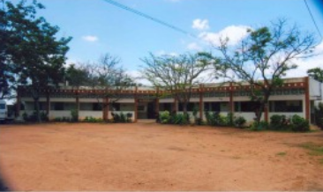

**About the Founders**

The vision of Renaissance was initiated by the philanthropists Mr. M.S. Thangavel, from Aranthangi and then the initial activities and management was headed by Mr.M.S.T. Chandrasekeran, Mr.P.Mahalingam, and Mr.K.Viswalingam.

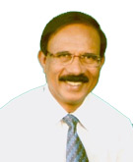

P.Mahalingam (Managing Trustee- Renaissance)

After 2002, the trust was spearheaded to greater heights with wider scope of activities under the able vision of the co-founder Mr.P. Mahalingam, who has dedicated his entire life towards the welfare of people and for the Children of the God.

**Recognitions**

In recognizing the good works being done, the Tamil Nadu Government under the Department of Social Defence certified Renaissance as the Reception Unit.

Recognized under the Juvenile Justice (Care and Protection of Children) Amendment Act 2006, as a children’s Home for the Mentally Challenged Destitute.

One among the 40 organizations in Tamil Nadu Registered under the National Trust (Department of Empowerment of Persons with Disabilities- Ministry of Social Justice and Empowerment).

Click to download this image

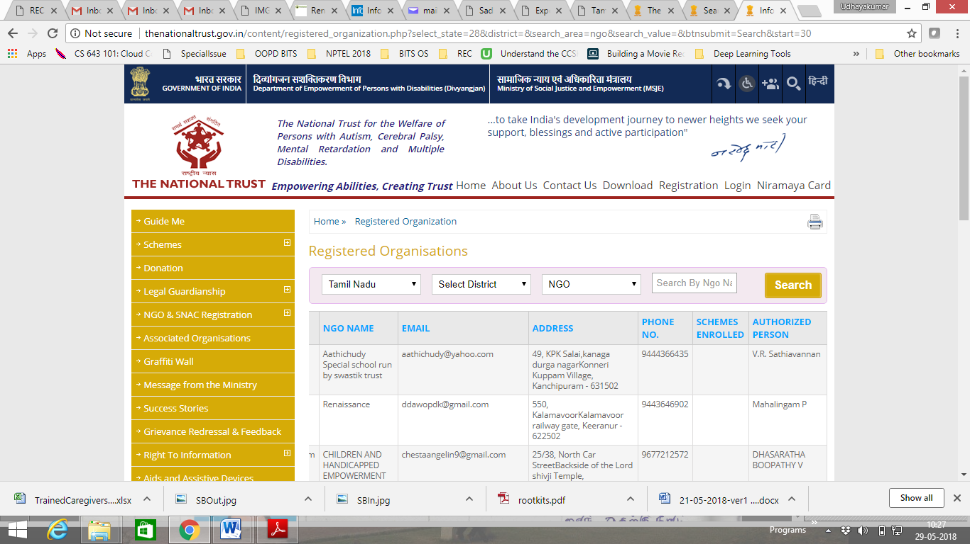

Declared a fit institution by the Child Welfare Committee, Government of Tamil Nadu

Registered under the Persons with Disabilities Act 1995

Given 12AA and 80G tax exemptions by the Income Tax department under the Income Tax Act 1961.

Registered under the Foreign Contribution Regulation Act (FCRA) 2010 to receive overseas donations.

**Vision**

To provide equality and affection for the intellectually challenged children and create a society with compassion that cares them as every other normal child.

**Mission**

Provide state of the art rehabilitation interventions through formal education by qualified people for persons with mental retardations.

Care and protect the MR children through research.

**Goal**

To act as a resource center for protection of rights, equal opportunity and full participation for the persons with mentally retardation.

**Aims & Objectives**

* To identify and Rehabilitate the persons with Intellectually Challenged Disability.
* To provide the Education for the Children with Mental Retardation and Multiple Disability.
* To provide the Vocational Training for the persons with mental retardation.
* Raise the funds through donations from organizations and individuals for better assistance and purchase advanced equipment’s to serve these children.
* To provide the residential facilities with medical care.
* To integrate the mentally handicapped children with normal children.
* To undertake and participate in programmes pertaining to health, education, employment, and rehabilitation of the disabled.
* To seek the collaboration and co-operation of other voluntary and Government agencies for development activities and programmes.
* To conduct and or participate in seminars, camps, conferences, research and training programmes.
* To aid and support deserving persons with disabilities and the aged wherever and whenever necessaries.
* To organise, undertake, co-ordinate guide, assist and promote integrated Rural Development approach.
* To help the rural innocent people in all activities and make them to participate in all existing Government programmes through our societies activities.
* To organise and undertake and develop Educational Institutions for needy and down trodden people, wherever and whenever necessary.
* To mobilize and organise the Rural Community in awareness and general education for development activities.
* To initiate and encourage the education of women, children and disabled on question regarding their rights and duties.
* To motivate and train rural mass about practicability and utility of Appropriate Technology and upgrade their capacity and skills.

**BOARD MEMBERS**

**Board of Trustee**

**Founder and Director**

**Dr. P. Mahalingam**

* **Received honorary “Doctorate for Humanity” for his 35 Years of Service towards social cause from the Academy of Universal Global Peace.**
* **He is presently a District Lok Adalat Member ( a Judiciary system of India - Legal Services Authorities Act, 1987)**
* **He is the District Secretary for Special Olympic Bharath.**
* **Committee member for National Trust ( A body under Govt. of India)**
* **Certified Special Education Teacher in the field of** 
  + **Yoga**
  + **Speech and Hearing Therapy**
  + **Vocational Training**
  + **Self Help Skill Training**
  + **Hearing**
  + **Counselling for Parents and Society**

**Address:**

RENAISSANCE MALARCHI RESIDENTIAL SCHOOL FOR MENTALLY RETARDED CHILDREN

Kalamavoor Village & Post, Off Trichy To Pudukottai Highway.

Keeranur Via, Pudukkottai District, Tamil Nadu, Southern India, PIN: 622 502, PHONE: 7373746904

Mobile: 9443646902

**e-mail:** [**mahaaren@gmail.com**](mailto:mahaaren@gmail.com)

**renaissance.mahalingam@gmail.com**

**Trustee Members**

**1. Mr.D.Gokul**

* Has an MBA, Presently working as a Medical Representative of the MNC (Wallace India) in Thanjavur.
* His contacts with Paediatricians in and around Pudukkotai district is of much help for the School Children.
* Actively involves in organizing events such as sports for special children, Self-Help skill training, Counselling and fund raising.

Address:

Kannagi Nagar,

Near New Bus Stand,

Thanjavur - 613007,

Mobile: 9994513102

E.mail : gokuldr82@gmail.com

**2. Ms.S.Rani**

A Social Worker instrumental in planning the day-to-day activities of the Trust, who has dedicated herself for the cause of these Children.

Address:

125, Kannagi Nagar,

Near New Bus Stand,

Thanjavur - 613007,

Mobile: 9994513102

**3. Mr.P.Manivanan**

An Experienced Business Person involved in Brand Marketing focused towards Foods and Beverages Business. Presently working as a Regional Manager (South India), for Siva Foods Pvt Limited.

His 25 years of expertise towards Food products helps in addressing the nutritional intake of these children’s .

Address:

Andavar Castle,

Andavar Street, Anna Nedum Pathai,

Choolaimedu, Chennai-600094.

Mobile: 8056014201

E.mail: mani_richesh@yahoo.com

**5. Mrs. Kavipriya Arul**

A PrimarySchoolTeacher at the Government School, Coimbatore.

Her experience in handling children in primary section helps in understanding the needs for activity based learning. Also her expertise helps to reach out to understand the behavioural ethics of interacting normal children with MR children.

Address:

Sheeba Nagar,

Kaniyur,

Coimbatore,

Tamil Nadu 641048

Mobile: 9445003544

E.mail: daruldurai@gmail.com

**6. Prof. Dr. S. Udhayakumar**

A Professor with a Doctorate (Ph.D) in the field of Computer Science and Engineering, Presently working in Rajalakshmi Engineering College, Chennai.

Actively Involved in maintain and updating websites, fund raising and doing research towards the betterment of MR children.

Address:

No: 36, Bala Murugan Castle,

Krishnapuram, Ambattur

Chennai-600053

Mobile: 9841593116

E.mail: mailtoudhay@gmail.com

**Legal Advisor**

Mr.Ganapathy Subramanium, B.A, B.L.

Advocate, High Court (Madurai)

**Auditor**

Mr.AR. Karuppanchetty, B.Com, F.C.A.,

Charted Accountant,

**Address:**

19, New Raja Colony,

Beema Nagar, Trichy- 620001,

Phone No. 2462739

**REGULAR STAFFS**

|  |  |  |  |
| --- | --- | --- | --- |
|  | **Name** | **Responsibility** | **Qualification** |
| 1 | R. Renuga | Special Educator | Diploma in Special Education, MR, B.Com, |
| 2 | Josphine Patricia | Special Educator | Diploma in Special Education, MR, B.A, |
| 3 | R.Raja Selvi | Special Educator Cum Vocational Instructor | Diploma in Special Education, MR. |
| 4 | A.Vinolia | Special Educator Cum Vocational Instructor | Diploma in Special Education, MR. |
| 5 | A.Vinci Rani | Special Educator | Diploma in Special Education, MR. |
| 6 | A. Vanitha | Warden | B.Sc |
| 7 | R.Banumathi | Food and Kitchen | - |
| 8 | R.Chellamal | Care taker | - |
| 9 | C.Ananda valli | Care taker | - |
| 10 | R.Dhanapal | Driver | - |
| 11 | S.Latha | Cook |  |
| 12 | R.Balasubramaniyan | Physiotherapist | B.P.T |

**REPORTS**

**(proofs – photo needed)**

**News Reports**

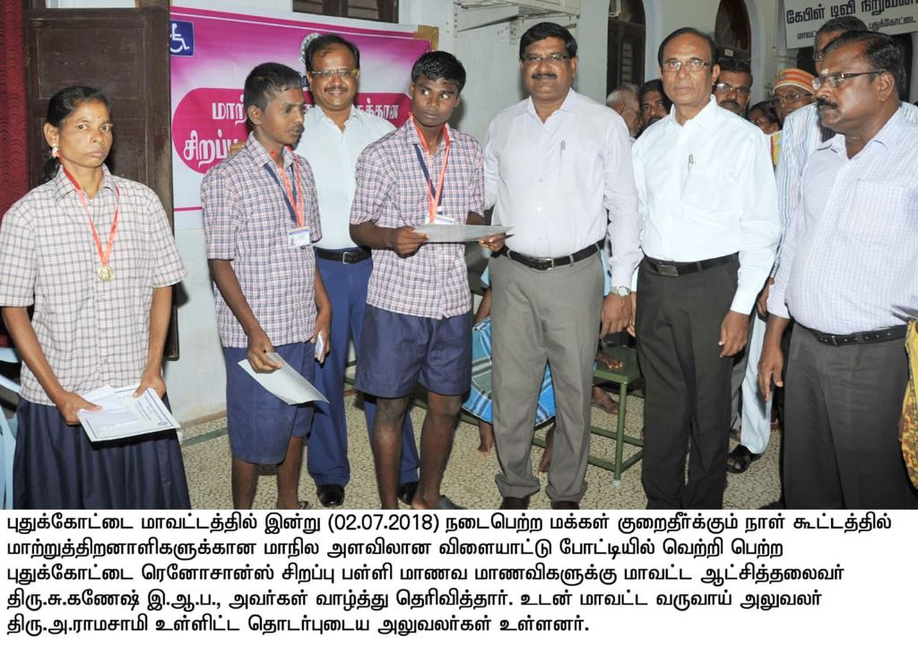

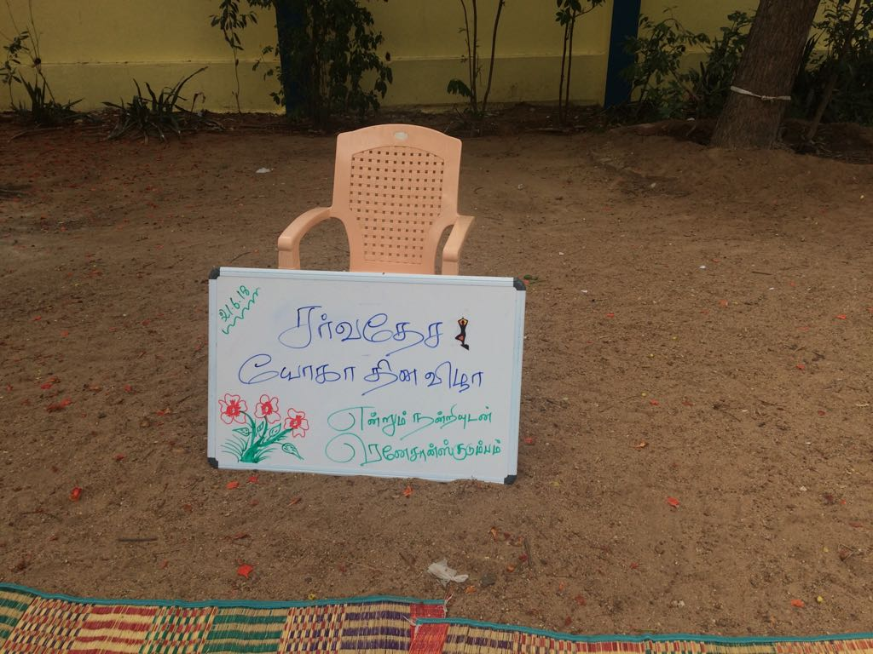

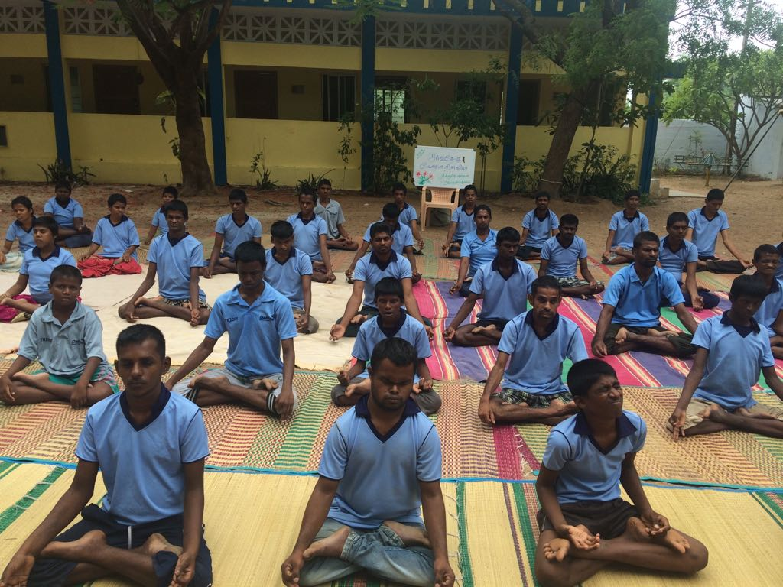

**Articles**

**Event Report**

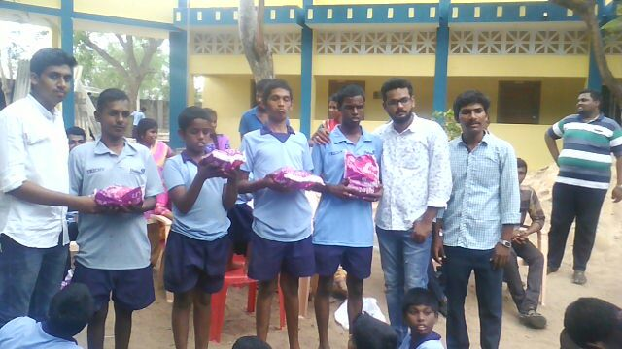

**Annual Report**

**Newsletter**

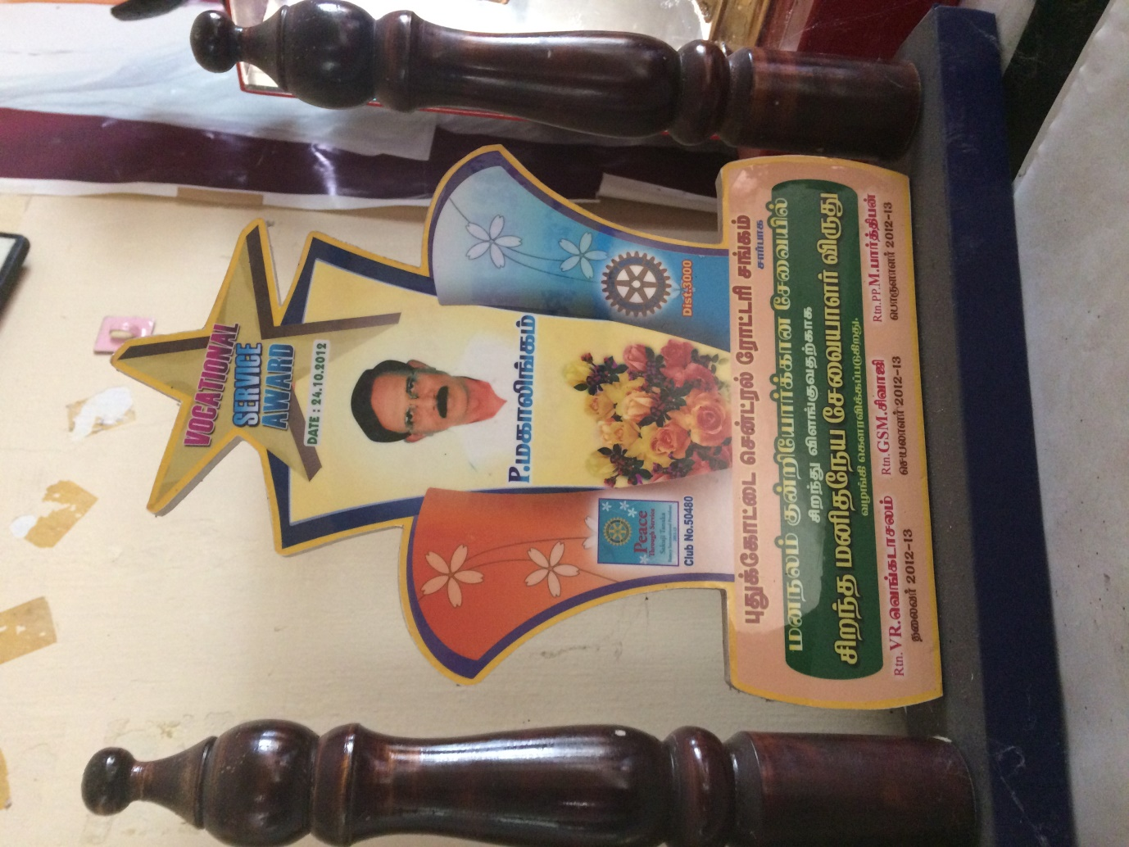

**Awards**

**DEVELOPMENT PROGRAMS ORGANIZED TILL DATE**

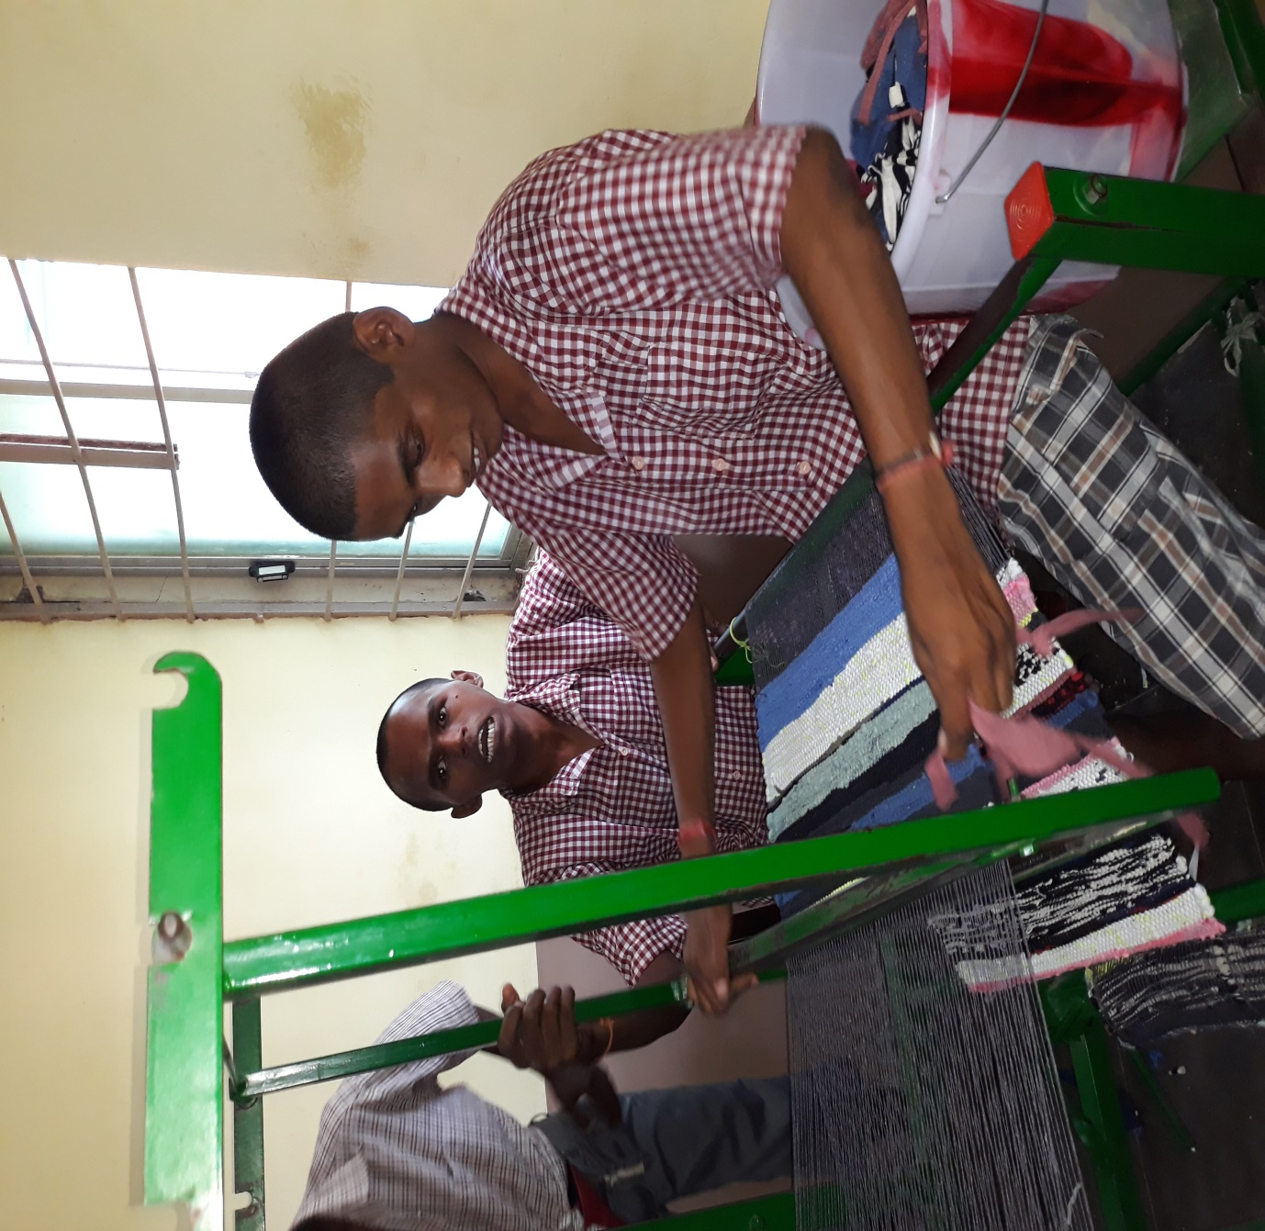

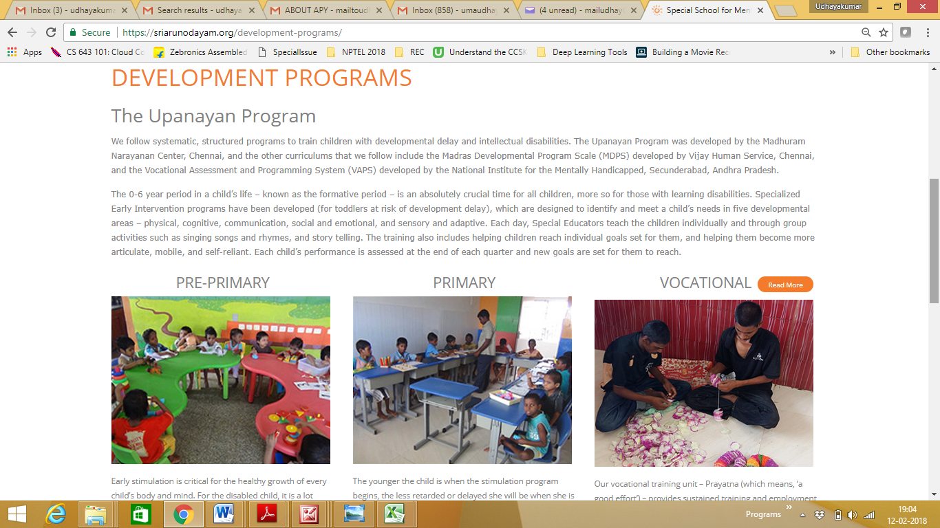

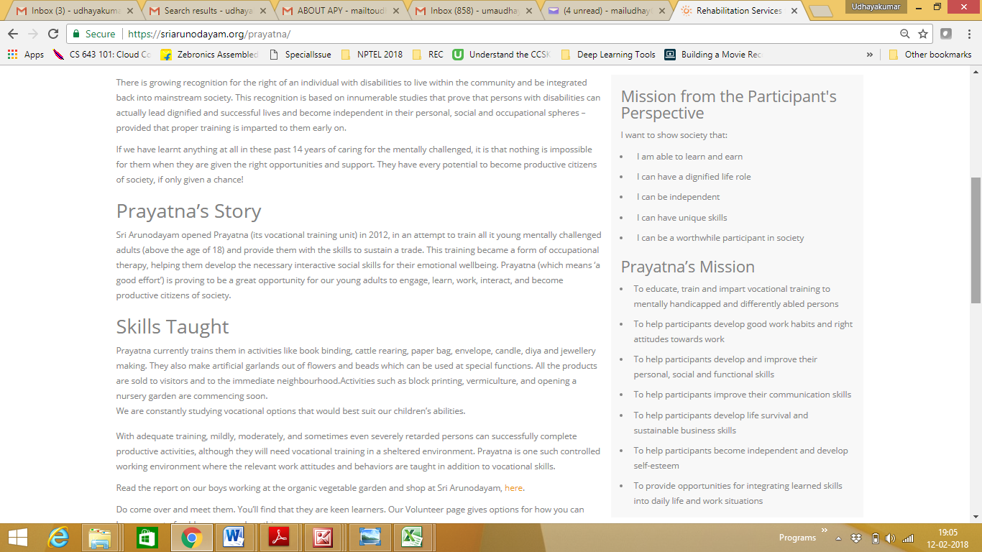

**Sponsors**

|  |  |  |
| --- | --- | --- |
|  |  | **Donation Amount** |
|  | **Sponsor a Meal** | **2000** |
|  | **Meal for a Day** | **5000** |
|  | **Vegetables for a Day** | **2000** |
|  | **Snacks and Milk** | **1000** |
|  | **Monthly recreational outing** | **7000** |
|  | **One time donation towards a child welfare** | **50,000** |
|  | **Other Expenses** | **Any Insurance towards Medical Expenses or savings schemes, LIC, Atal Pension Yogna, or any Govt. linked funds.** |

**For a Child**

|  |  |  |
| --- | --- | --- |
|  |  | **Donation Amount** |
| **1** | **Living Expense for a Month** | **4000** |
|  | **Sponsor a Dress** | **500** |
|  | **Diaper for a month** | **500** |
|  | **Psychiatrics treatment for a month** | **750** |
|  | **Physiotherapy treatment for a month** | **1500** |
|  | **Sponsor for annual check up** | **3000** |
|  | **Sponsor physiotherapy equipment** | **Min. 5000** |
|  |  |  |

**For School**

|  |  |  |
| --- | --- | --- |
|  |  | **Donation Amount** |
|  | **Washing machine\*** | **20,000** |
|  | **Grinder\*** | **5000** |
|  | **Play equipment’s** | **200-2000** |
|  | **Any Monitoring Device\*** | **5000-15000** |
|  |  |  |

*based on requirements

**DONATIONS**

**Domestic Wire Transfer**

|  |  |
| --- | --- |
| Bank Name | CITY UNION BANK |
| Branch | PULIYUR |
| Account Number | 079001001686794 |
| Name of the Account | RENAISSANCE |
| MICR code | 520054103 |
| Type of Account | SAVINGS BANK (SB) |
| IFSC code | CIUB0000079 |
| Address of the Bank | PULIYUR, PUDUKOTTAI, TIRCHY MAIN ROAD, KULATHUR THALUK, PUDUKOTTAI DISTRICT |
| Contact Phone Number | 9443646902, 9841593116, (04339) 262527 |
| District and State | PUDUKOTTAI DISTRICT, TAMIL NADU, INDIA |

**Cheque**

|  |  |
| --- | --- |
| Cheque Payable to | RENAISSANCE |
| Account Number | 079001001686794 |